Cognitive elements implicit in arguments about mechanisms of organic reactions. An approach based on cognitive psychology

Abstract
This paper aims to access elements of cognitive reasoning implicit in subjects related to mechanisms of organic reactions based on the Conceptual Fields Theory of Gerard Vergnaud. We proposed a situation of open character with a focus on organic reactions. Undergraduate students and the teacher responsible for the course of Organic Chemistry Basic were asked to orally explain how to solve the task done. Textual Analysis was performed with the aid of Discursive Transana software in three dimensions: concepts involved, the structure of arguments and gestural features. The data suggest keeping the elements essential to cognitive learning of Organic Chemistry proposed by Mullins (2008) with the idea of ​​invariant-operative Gerard Vergnaud. However, there is a need for association of these elements in a coherent and organized in the cognitive structure of the subject to which these elements acquire instrumental value to associate themselves with justifications for solving tasks.

Introduction and Objectives
Vergnaud defines Conceptual Field as a set of concepts, issues, procedures and symbolic representations closely intertwined during solving situations (tasks) (VERGNAUD, 2009; MOREIRA 2002). The concepts concerning mechanisms of reactions in undergraduate courses constitute a conceptual field within the meaning of Vergnaud while it is necessary both symbolic representation as a deep understanding of structural factors which underlie concepts of chemical bonding, inductive effects, among others. The literature also have pointed out that besides the difficulties of conceptualization, visuospatial skills are required (Engida and Barke, 2001). Vergnaud (2009) takes the concept of Piagetian schema as organizer of thought and is activated when subjects interact with a task. Thus, the resolution of tasks requires the activation of a particular set of schemas that include goals and anticipations, rules of inference, action possibilities and operational invariants (theorems-in-action and concepts-in-action). The operational invariants assume a central role in the action, as they determine the nature of the concepts themselves.
Regarding the teaching of concepts of Organic Chemistry, Mullins (2008) proposes that there be fundamental elements that would structure the planning activities aimed at undergraduate students as well as the narratives developed in the classroom. The good performance would result from the suitable domain of these basic elements which are, electronegativity, polar covalent bond, steric effect, inductive effect, resonance and aromaticity, as they would have instrumental value in solving tasks, alone or in combinations.
This paper aims to access the operational invariants in open situations on a course of organic chemistry as well study the dynamics of these cognitive elements on solving tasks.

Methodology
This research involved seventeen Chemistry undergraduate students enrolled in a course of basic Organic Chemistry from the Universidade Federal do ABC (S1-S17) and the subject teacher (S18). It was proposed an open situation on organic chemistry for the students and to the teacher responsible for the course. These subjects were asked to discuss nucleophilic substitution reactions and unimolecular and bimolecular elimination. Also are provided five scenarios. Research participants should choose which would be most likely for the chemical transformation proposal, explaining in detail the reasons of this choice (Figure 1).
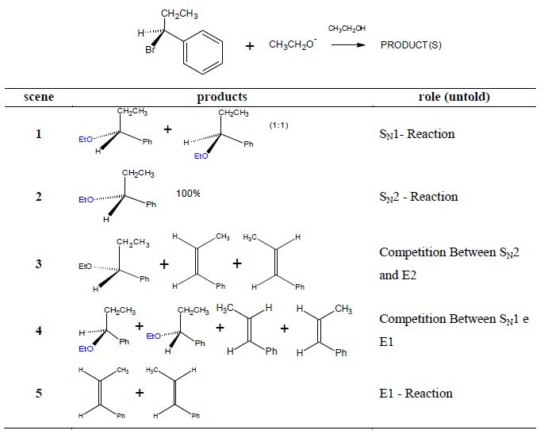
Figure 1 – Planning for Instrument for Data Collection
At the time of data collection the participants were already finalizing the basic discipline of Organic Chemistry. Moreover, the subject teacher has organized the topics of this course due to the proposed Mullins (2008). Thus, the situation was presented to students without time restrictions and without access to any kind of consultation. They were instructed to value their arguments in the six structural elements proposed by Mullins (2008). Finally participants were asked to orally spell out the reasoning employed in the resolution.
The semi-structured interviews were recorded on audio and video material for constituting the Textual Analysis as proposed by Galiazzi and Moraes (2006) and performed with the Transana software (Woods, 2012). These authors propose the fragmentation of the text in manageable subsets, called units of meaning. The assigning meanings to these units were made based on criteria organized into three dimensions: conceptual, arguments and gestural features. The conceptual dimension was categorized according to the definitions proposed by Vergnaud (1996) for operational invariants (theorems-in-action and concepts-in-action). This dimension of analysis is the conceptual core implicit in the actions of individuals who participated in the survey, ie the fundamental elements proposed by Mullins (2008) for learning of Organic Chemistry. Already a dimension related to the arguments was based on the model of argumentation of Toulmin (Toulmin, 1958; Sa and Queiroz, 2007). Finally, the categorization of gestural resources is on the field of linguistic studies conducted by McNeill (1992). Table 1 shows the structure adopted for data analysis.

Table 1– Dimensões e categorias adotadas na análise dos dados.

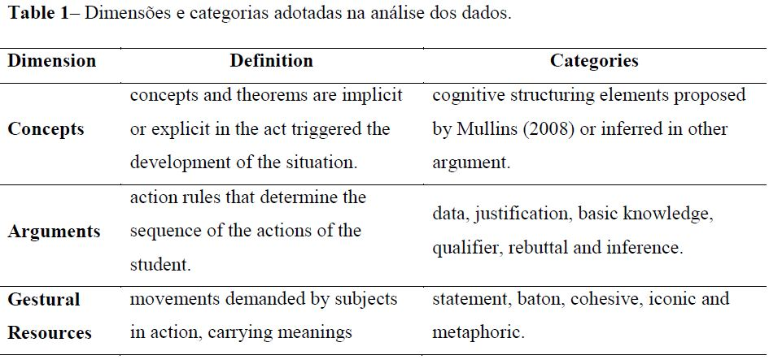
Results
Among the proposed scenarios in Figure 1, the fourth Scene is feasible via competition between the reaction of unimolecular elimination and substitution. The third would only be possible when considering mechanistic competition (uni and bimolecular). Table 2 shows the choices made ​​by the participants of the research in the written assessment:

Table 2 - Overview of the scenarios chosen by the students.
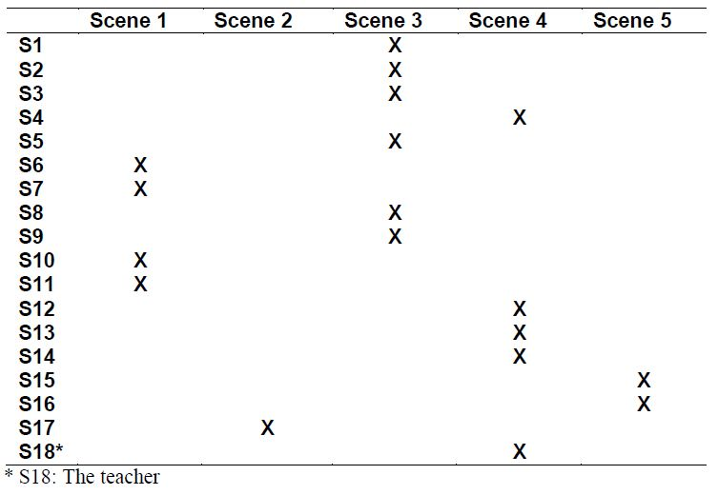

The Inspection of the written production of students who chose the same scenario (S4, S12, S13 and S14, Scene 4) showed frequent use of the elements proposed by Mullins (2008) as requested. However, none of these students joined these elements with justifications about the stability of the reaction intermediate.
Additional information about the process of conceptualization were accessed via diagrams constructed with the aid of software Transana based on oral justifications (Figures 2 and 3). In the case of S18 and S1 subjects, although opted for different Scenes, the construction of justifications buoyed by knowledge-based on nature conceptual as well the use of data and inferences are very similar in these subjects. Moreover, both value the stereochemistry of the reaction intermediate as complementary concept-in-action to discuss the mechanistic pathway. Despite these similarities, S1 concludes differently to S18 possibly by not thinking about the possibility of stabilization on the reaction intermediate by resonance.

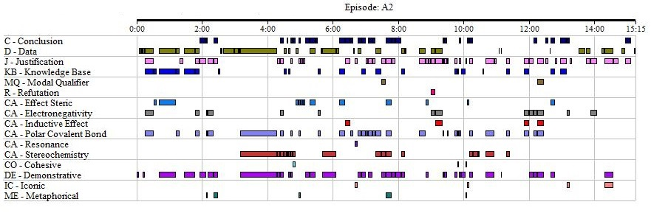
Figure 2: Transana´s diagram from S1.

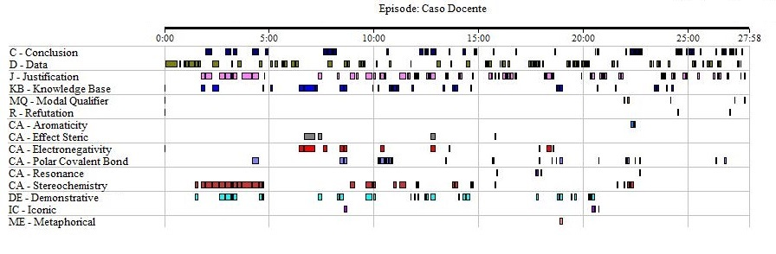
Figure 3: Transana´s diagram from S18.

Conclusion
The data suggest consonance between the structural elements of learning in Organic Chemistry proposed by Mullins (2008) as the idea of invariant operative Gerard Vergnaud. It is worth mentioning the role of the combination of multiple operational invariants often with the role to become operational the justifications in the schemas of the subjects. While there is a need for further research on this phenomenon, we suggest that the organization of these cognitive elements associated and linked to justifications in discourse, can promote the construction of an instrumental value for the resolution of tasks.

Bibliography
Barke, H.D.; Engida, T. (2001). Structural chemistry and spatial ability in different cultures. Chemistry education: research and practice in Europe , v. 2, n. 3, p. 227-239.
Galiazzi, M. C.; Moraes, R. (2006). Análise textual discursiva: processo reconstrutivo de múltiplas faces. Ciência & Educação , v. 12, n. 1, p. 117-128.
Mcneill, D. (1992). Hand and mind : what gestures reveal about thought. Chicago: University of Chicago Press.
Moreira, M. A. (2002). A Teoria dos Campos Conceituais de Vergnaud, o ensino de ciências e a pesquisa nesta área. Investigações em ensino de ciências , v. 7, n. 1.
Mullins, J. J. (2008). Six Pillars of Organic Chemistry. Journal Of Chemical Education, V. 85, n.1, p. 83-87.
Vergnaud, G. (1996) Algunas ideas fundamentales de piaget en torno de la didactica. Perspectivas, v. 26, n. 1, p. 195–207.
Vergnaud, G. (2009). The Theory of Conceptual Fields. Human Development , v. 52, n. 2, p. 83-9.
SÁ, L. P. ; Queiroz, S. L. (2007) . Promovendo a argumentação no ensino superior de química. Química Nova (Impresso), v. 30, p. 2035-2042.
Toulmin, S. (1958) The uses of argument. Cambridge: Cambridge University Press.
Woods, C. F. A. D. K. (2012) Transana. In: 2.51B (Ed.). 2.51b. Madison: Wisconsin Center for Education Research of University of Wisconsin-Madison.

